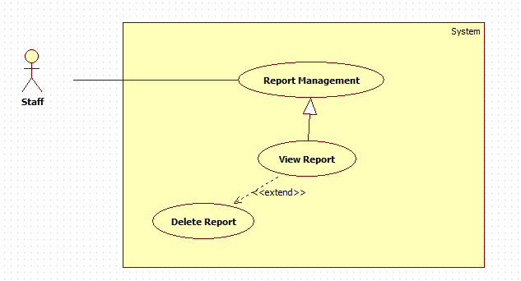

|  |  |  |  |
| --- | --- | --- | --- |
| **USE CASE – AD007** | | | |
| **Use Case No.** | AD007 | **Use Case Version** | 2.0 |
| **Use Case Name** | Report Management | | |
| **Author** | Ho Dac Nghia | | |
| **Date** | 15/01/2014 | **Priority** | Normal |
| **Actor:** Staff  **Summary:**  The user case allow staff to view report and delete report  **Goal:**  The staff can view all reports of user.  The staff can delete reports that saved in database.  **Triggers:**   * Click menu item "Report Management" -> "Report List" * On the Report List, click Details to view details of report. * Click "Delete" to delete report   **Preconditions:**   * User must logged in the system with the role is staff. * There must be at least one report in the report list   **Post Conditions:**   * **Success:** The report of a traffic sign will be removed from server and database * **Fail:** No report removed   **Main Success Scenario:**   |  |  |  | | --- | --- | --- | | Step | Actor Action | System Response | | 1 | Click menu item “Manage User Report” -> “Report List”.  [Alternative 1] | Redirect to Report List Page, contains :  • Table with 4 columns, record of 20 latest report:  - Report Code: label  - Username: label  - Traffic code: label  - Detail: “Detail” button | | 2 | Click on “Detail” button | Redirect to Report Detail Page, contains detail of User’s Report, include:  • Traffic sign code.  • Account’s name.  • Detail of report.  • Delete button. | | 3 | Click on the “Delete” button | Show confirms windows with message:  “Are you sure to delete this report?” | | 4 | Click “Ok” button.  [Alternative 2] | The selected report will be removed from server and database.  An message is display: “Report XXX removed”. |   **Alternative Scenario:**   |  |  |  | | --- | --- | --- | | No | Actor Action | System Response | | 1 | [Alternative 2]  Click “Cancel” | The report is not removed. | | | | |

**Exceptions:** N/A

**Relationships:** Manage Report

**Business Rules:** N/A

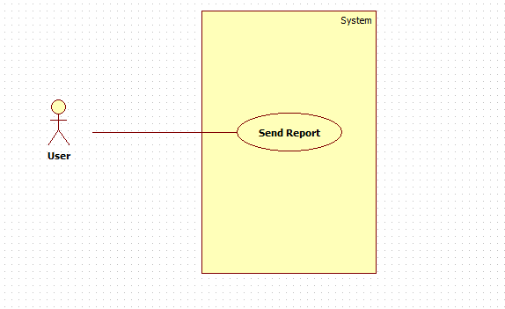

|  |  |  |  |
| --- | --- | --- | --- |
| **USE CASE – AD007** | | | |
| **Use Case No.** | AD007 | **Use Case Version** | 2.0 |
| **Use Case Name** | Send Report | | |
| **Author** | Ho Dac Nghia | | |
| **Date** | 15/01/2014 | **Priority** | Normal |
| **Actor:** User  **Summary:**  The user case allow user to send report about information of traffic sign **Goal:**  The user can send report  **Triggers:**  To manage report user must:  -Choose the Traffic Sign want to Report. - Click button "Send Report" -> "Report Page" - On the Report Page, user input details of report. - Click "Submit" to send report. **Preconditions:**   * User must logged in the system with the role is user. * There user must choose one traffic sign for report   **Post Conditions:**  **Success:** The report of a traffic sign will be save on server and database  **Fail:** No report send.  **Main Success Scenario:**   |  |  |  | | --- | --- | --- | | Step | Actor Action | System Response | | 1 | Choose the Traffic Sign -> Click "Send Report" button.  [Alternative 1] | Redirect to Report Send Page, contains :  - Traffic code: label  - Account name: label  - Test area for User input detail of report.  - "Submit" button.  - "Reset" button. | | 2 | Click on “Submit” button | Show confirms windows with message:  “Are you sure to send this report?” | | 3 | Click on the “Delete” button | Show confirms windows with message:  “Are you sure to delete this report?” | | 4 | Click “Ok” button.  [Alternative 2] | The selected report will be send to server and database.  An message is display: “Report send successful”. |   **Alternative Scenario:**   |  |  |  | | --- | --- | --- | | No | Actor Action | System Response | | 1 | [Alternative 2]  Click “Cancel” | The report is not send. | | | | |
|  | | | |

**Exceptions:** N/A

**Relationships:** Send Report

**Business Rules:** N/A

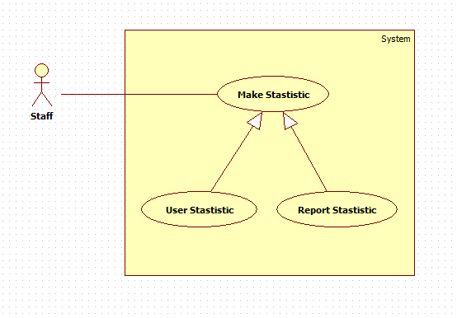

|  |  |  |  |
| --- | --- | --- | --- |
| **Use Case Name** | Make Statistics | | |
| **Author** | Ho Dac Nghia | | |
| **Date** | 15/01/2014 | **Priority** | Normal |
| **Actor:** Staff  **Summary:**  This user case allow staff to make Statistics about User and Report.  **Goal:**   * Have Statistics information about user or report.   **Triggers:**   * Click menu item “Make Statistics” -> “Drop down list” have 2 item Statistic User and Statistic Report * Click on “Statistic User” -> Statistics info of User * Click on “Statistics Report” -> Statistics info of Report   **Preconditions:**   * User must logged in the system with the role is staff.   **Post Conditions:**   * **Success:** Statistics info of User or Report were displayed. * **Fail:** No statistics info displayed.   **Main Success Scenario:**   |  |  |  | | --- | --- | --- | | Step | Actor Action | System Response | | 1 | Click menu item“Make Statistics”  [Alternative 1] | Dropdown list, contains :   * Statistics User * Statistics Report | | 2 | Click on “Statistics User” button | Redirect to Statistics Detail Page, contains detail of User’s Statistics | | 3 | Click on “Statistics Report” button | Redirect to Statistics Detail Page, contains detail of Report’s Statistics |   **Exceptions:** N/A  **Relationships:** Make Statistics  **Business Rules:** N/A | | | |